**Name : Anish Patial  
UID : 22BCS15029**

**SEC : Fl_Iot 601 ‘A’**

**Ap experiment 9**

1. Number of Islands

class Solution {

 public:

  int numIslands(vector<vector<char>>& grid) {

    constexpr int kDirs[4][2] = {{0, 1}, {1, 0}, {0, -1}, {-1, 0}};

    const int m = grid.size();

    const int n = grid[0].size();

    int ans = 0;

    auto bfs = [&](int r, int c) {

      queue<pair<int, int>> q{{{r, c}}};

      grid[r][c] = '2';

      while (!q.empty()) {

        const auto [i, j] = q.front();

        q.pop();

        for (const auto& [dx, dy] : kDirs) {

          const int x = i + dx;

          const int y = j + dy;

          if (x < 0 || x == m || y < 0 || y == n)

            continue;

          if (grid[x][y] != '1')

            continue;

          q.emplace(x, y);

          grid[x][y] = '2';

        }

      }

    };

    for (int i = 0; i < m; ++i)

      for (int j = 0; j < n; ++j)

        if (grid[i][j] == '1') {

          bfs(i, j);

          ++ans;

        }

    return ans;

  }

};

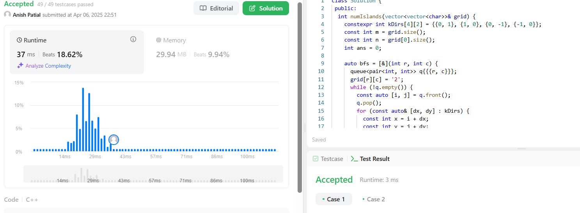

1. [**Word Ladder**](https://leetcode.com/problems/word-ladder/)

class Solution {

public:

int ladderLength(string beginWord, string endWord, vector<string>& wordList) {

unordered_set<string> wordSet(wordList.begin(), wordList.end());

if (!wordSet.contains(endWord))

return 0;

queue<string> q{{beginWord}};

for (int step = 1; !q.empty(); ++step)

for (int sz = q.size(); sz > 0; --sz) {

string word = q.front();

q.pop();

for (int i = 0; i < word.length(); ++i) {

const char cache = word[i];

for (char c = 'a'; c <= 'z'; ++c) {

word[i] = c;

if (word == endWord)

return step + 1;

if (wordSet.contains(word)) {

q.push(word);

wordSet.erase(word);

}

}

word[i] = cache;

}

}

return 0;

}

};

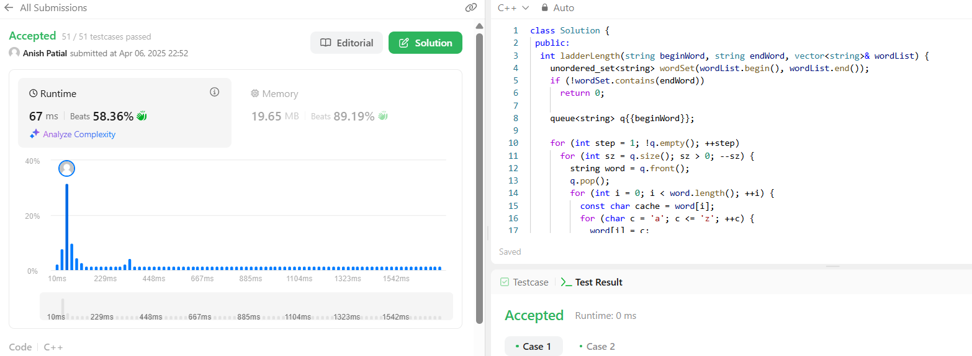

1. [**Surrounded Regions**](https://leetcode.com/problems/surrounded-regions/)

class Solution {

 public:

  void solve(vector<vector<char>>& board) {

    if (board.empty())

      return;

    constexpr int kDirs[4][2] = {{0, 1}, {1, 0}, {0, -1}, {-1, 0}};

    const int m = board.size();

    const int n = board[0].size();

    queue<pair<int, int>> q;

    for (int i = 0; i < m; ++i)

      for (int j = 0; j < n; ++j)

        if (i * j == 0 || i == m - 1 || j == n - 1)

          if (board[i][j] == 'O') {

            q.emplace(i, j);

            board[i][j] = '*';

          }

    while (!q.empty()) {

      const auto [i, j] = q.front();

      q.pop();

      for (const auto& [dx, dy] : kDirs) {

        const int x = i + dx;

        const int y = j + dy;

        if (x < 0 || x == m || y < 0 || y == n)

          continue;

        if (board[x][y] != 'O')

          continue;

        q.emplace(x, y);

        board[x][y] = '*';

      }

    }

    for (vector<char>& row : board)

      for (char& c : row)

        if (c == '*')

          c = 'O';

        else if (c == 'O')

          c = 'X';

  }

};

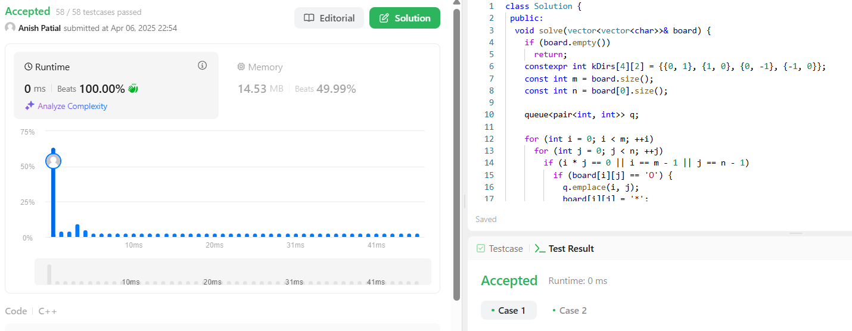

1. [**Binary Tree Maximum Path Sum**](https://leetcode.com/problems/binary-tree-maximum-path-sum/)

class Solution {

 public:

  int maxPathSum(TreeNode* root) {

    int ans = INT_MIN;

    maxPathSumDownFrom(root, ans);

    return ans;

  }

 private:

  int maxPathSumDownFrom(TreeNode* root, int& ans) {

    if (root == nullptr)

      return 0;

    const int l = max(0, maxPathSumDownFrom(root->left, ans));

    const int r = max(0, maxPathSumDownFrom(root->right, ans));

    ans = max(ans, root->val + l + r);

    return root->val + max(l, r);

  }

};

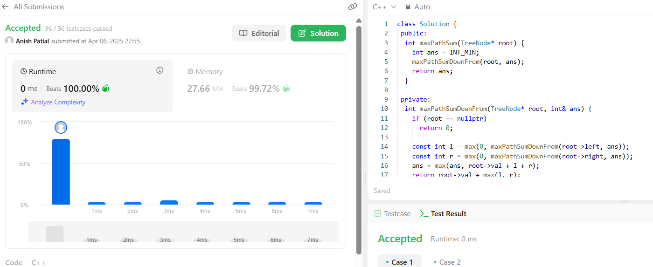

1. [**Number of Provinces**](https://leetcode.com/problems/number-of-provinces/)

class UnionFind {

public:

UnionFind(int n) : count(n), id(n), rank(n) {

iota(id.begin(), id.end(), 0);

}

void unionByRank(int u, int v) {

const int i = find(u);

const int j = find(v);

if (i == j)

return;

if (rank[i] < rank[j]) {

id[i] = j;

} else if (rank[i] > rank[j]) {

id[j] = i;

} else {

id[i] = j;

++rank[j];

}

--count;

}

int getCount() const {

return count;

}

private:

int count;

vector<int> id;

vector<int> rank;

int find(int u) {

return id[u] == u ? u : id[u] = find(id[u]);

}

};

class Solution {

public:

int findCircleNum(vector<vector<int>>& isConnected) {

const int n = isConnected.size();

UnionFind uf(n);

for (int i = 0; i < n; ++i)

for (int j = i; j < n; ++j)

if (isConnected[i][j] == 1)

uf.unionByRank(i, j);

return uf.getCount();

}

};

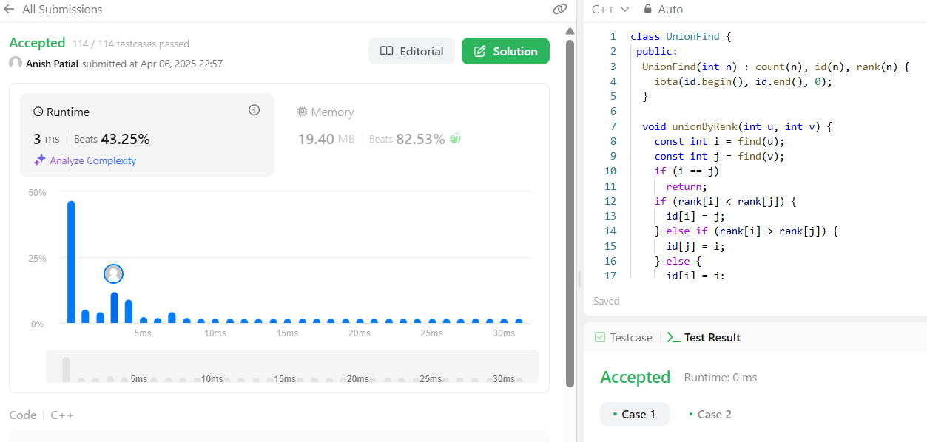

1. [**Lowest Common Ancestor of a Binary Tree**](https://leetcode.com/problems/lowest-common-ancestor-of-a-binary-tree/)

class Solution {

public:

TreeNode* lowestCommonAncestor(TreeNode* root, TreeNode* p, TreeNode* q) {

if (root == nullptr || root == p || root == q)

return root;

TreeNode* left = lowestCommonAncestor(root->left, p, q);

TreeNode* right = lowestCommonAncestor(root->right, p, q);

if (left != nullptr && right != nullptr)

return root;

return left == nullptr ? right : left;

}

};

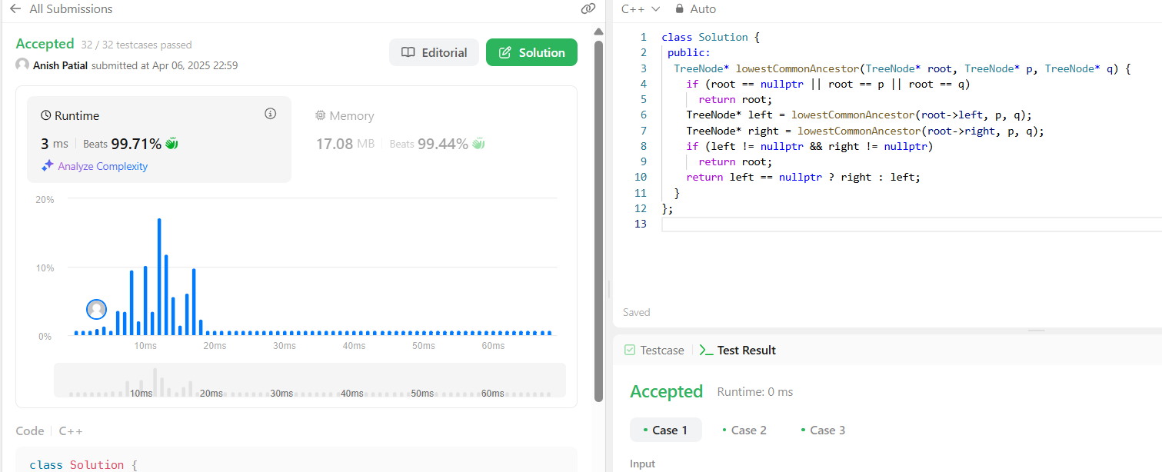

1. Course Schedule

enum class State { kInit, kVisiting, kVisited };

class Solution {

public:

bool canFinish(int numCourses, vector<vector<int>>& prerequisites) {

vector<vector<int>> graph(numCourses);

vector<State> states(numCourses);

for (const vector<int>& prerequisite : prerequisites) {

const int u = prerequisite[1];

const int v = prerequisite[0];

graph[u].push_back(v);

}

for (int i = 0; i < numCourses; ++i)

if (hasCycle(graph, i, states))

return false;

return true;

}

private:

bool hasCycle(const vector<vector<int>>& graph, int u,

vector<State>& states) {

if (states[u] == State::kVisiting)

return true;

if (states[u] == State::kVisited)

return false;

states[u] = State::kVisiting;

for (const int v : graph[u])

if (hasCycle(graph, v, states))

return true;

states[u] = State::kVisited;

return false;

}

};

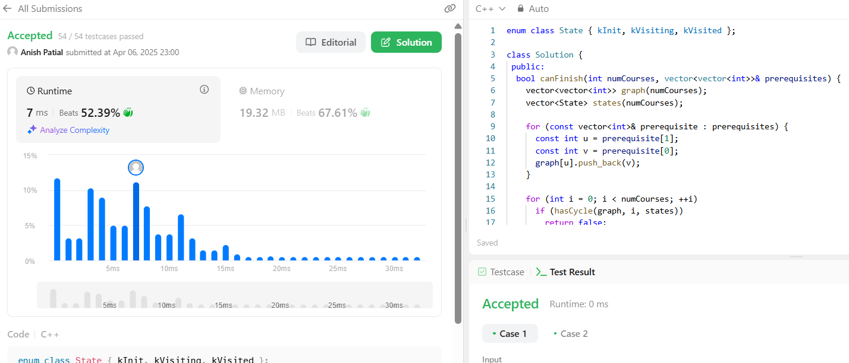

1. [**Longest Increasing Path in a Matrix**](https://leetcode.com/problems/longest-increasing-path-in-a-matrix/)

class Solution {

 public:

  int longestIncreasingPath(vector<vector<int>>& matrix) {

    const int m = matrix.size();

    const int n = matrix[0].size();

    int ans = 0;

    vector<vector<int>> mem(m, vector<int>(n));

    for (int i = 0; i < m; ++i)

      for (int j = 0; j < n; ++j)

        ans = max(ans, dfs(matrix, i, j, INT_MIN, mem));

    return ans;

  }

 private:

  int dfs(const vector<vector<int>>& matrix, int i, int j, int prev,

          vector<vector<int>>& mem) {

    if (i < 0 || i == matrix.size() || j < 0 || j == matrix[0].size())

      return 0;

    if (matrix[i][j] <= prev)

      return 0;

    int& ans = mem[i][j];

    if (ans > 0)

      return ans;

    const int curr = matrix[i][j];

    return ans = 1 + max({dfs(matrix, i + 1, j, curr, mem),

                          dfs(matrix, i - 1, j, curr, mem),

                          dfs(matrix, i, j + 1, curr, mem),

                          dfs(matrix, i, j - 1, curr, mem)});

  }

};

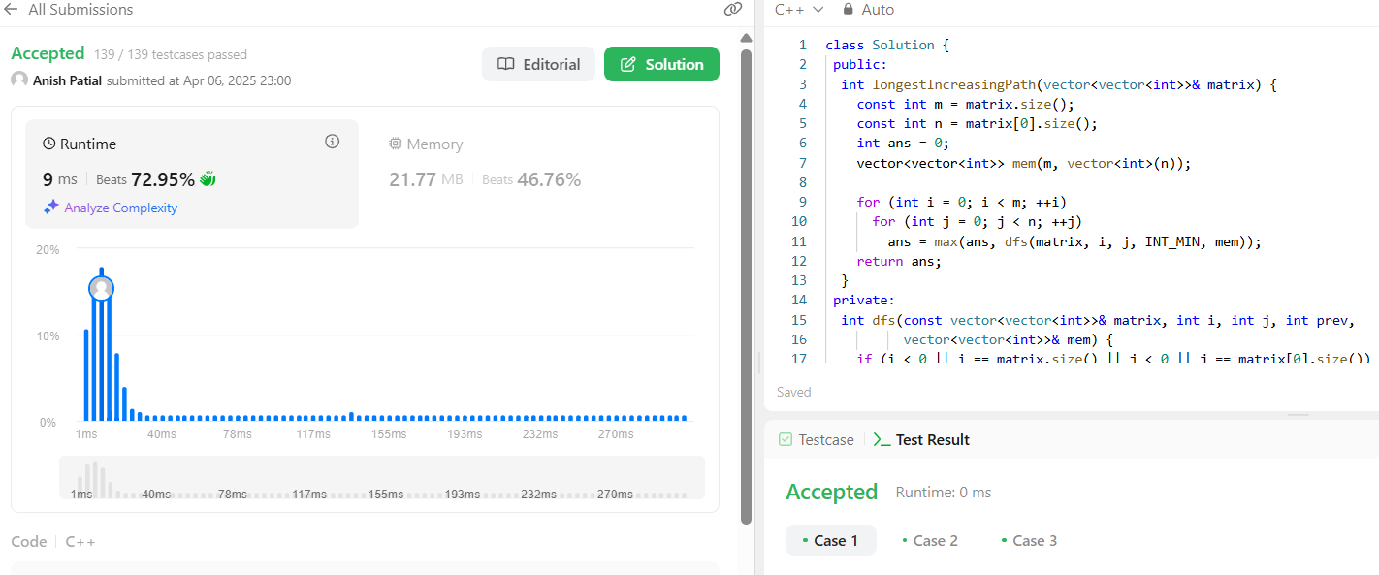

1. [**Course Schedule II**](https://leetcode.com/problems/course-schedule-ii/)

enum class State { kInit, kVisiting, kVisited };

class Solution {

public:

vector<int> findOrder(int numCourses, vector<vector<int>>& prerequisites) {

vector<int> ans;

vector<vector<int>> graph(numCourses);

vector<State> states(numCourses);

for (const vector<int>& prerequisite : prerequisites) {

const int u = prerequisite[1];

const int v = prerequisite[0];

graph[u].push_back(v);

}

for (int i = 0; i < numCourses; ++i)

if (hasCycle(graph, i, states, ans))

return {};

ranges::reverse(ans);

return ans;

}

private:

bool hasCycle(const vector<vector<int>>& graph, int u, vector<State>& states,

vector<int>& ans) {

if (states[u] == State::kVisiting)

return true;

if (states[u] == State::kVisited)

return false;

states[u] = State::kVisiting;

for (const int v : graph[u])

if (hasCycle(graph, v, states, ans))

return true;

states[u] = State::kVisited;

ans.push_back(u);

return false;

}

};

